**Elastic load balancer**

**Elastic load balancer is a service provided by Amazon in which the incoming traffic is efficiently automatically distributed across a group of backend servers in a manner that increases speed and performance.**

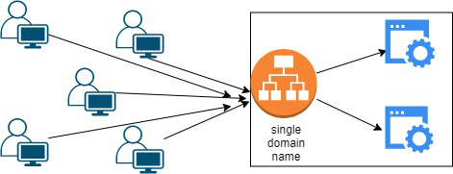

**Application Load Balancer - HTTP and HTTPS traffic routing**

**This load balancer works at the Application layer of the OSI Model**

**Network Load Balancer - This type of load balancer works at the transport layer(TCP/SSL) of the OSI model.**

**Gateway Load Balancer - It’s capable of handling millions of requests per second.**

**Launch ec2**

**Userdata amazon linux ec2**

**#!/bin/bash**

**sudo yum update -y**

**sudo amazon-linux-extras install nginx1 -y**

**sudo systemctl enable nginx**

**sudo systemctl start nginx**

**Ubuntu**

**#!/bin/bash**

**sudo apt update -y**

**sudo apt install nginx -y**

**sudo systemctl enable nginx**

**sudo systemctl start nginx**

**echo "<h1>Hello World from $(hostname -f)</h1>" > /var/www/html/index.html**

**Or**

**#!/bin/bash**

**sudo apt update**

**sudo apt install apache2 wget unzip -y**

**wget https://www.tooplate.com/zip-templates/2132_clean_work.zip**

**unzip 2132_clean_work.zip**

**sudo cp -r 2132_clean_work/* /var/www/html/**

**sudo systemctl restart apache2**

**#!/bin/bash**

**# Use this for your user data (script from top to bottom)**

**# install httpd (Linux 2 version)**

**yum update -y**

**yum install -y httpd**

**systemctl start httpd**

**systemctl enable httpd**

**echo "<h1>Hello World from $(hostname -f)</h1>" > /var/www/html/index.html**

**#!/bin/bash**

**#install httpd**

**sudo yum update -y**

**sudo yum install -y httpd**

**systemctl start httpd**

**systemctl enable httpd**

**echo "<h1>Hello World from $(hostname -f)</h1>" > /var/www/html/index.html**

### **Steps to configure an Application load balancer in AWS:**

**Step 1: Launch the two instances on the AWS management console named Instance A and Instance B. Go to services and select load balancer**

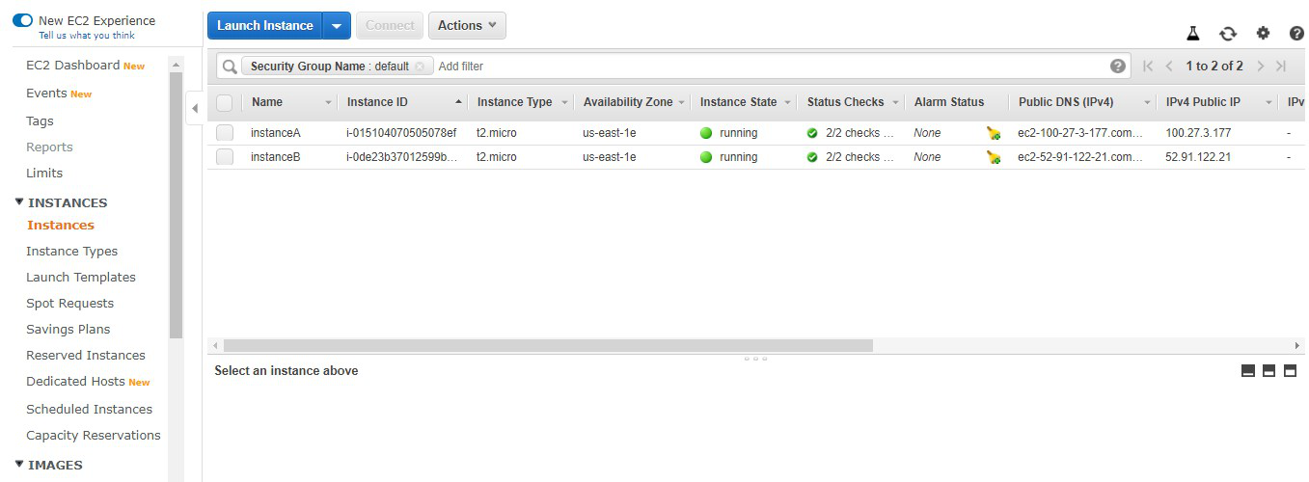

**Step 2: Click on create load balancer.**

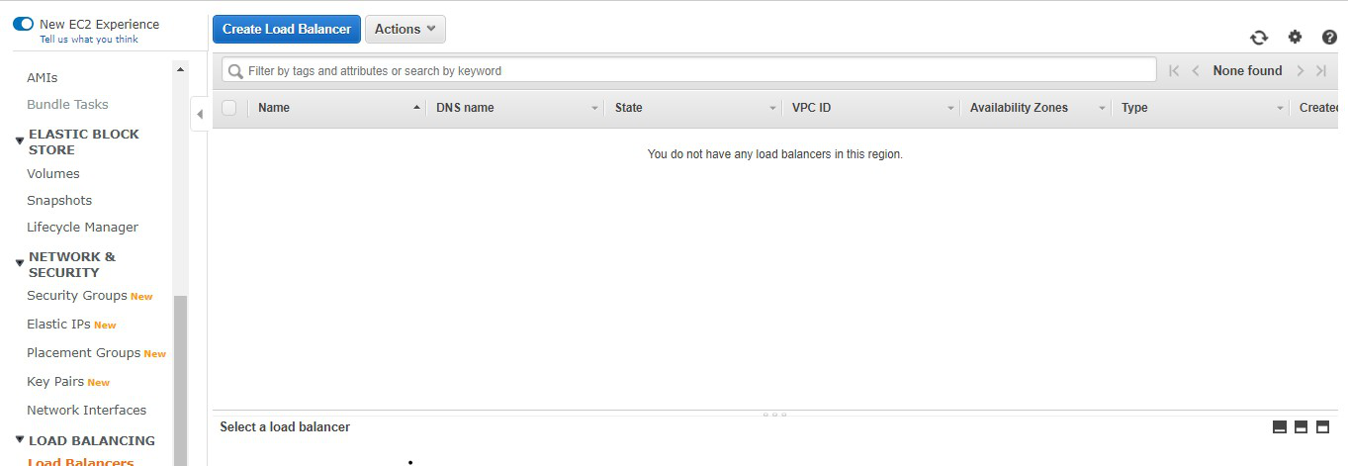

**Step 3: Select Application Load Balancer and click on create.**

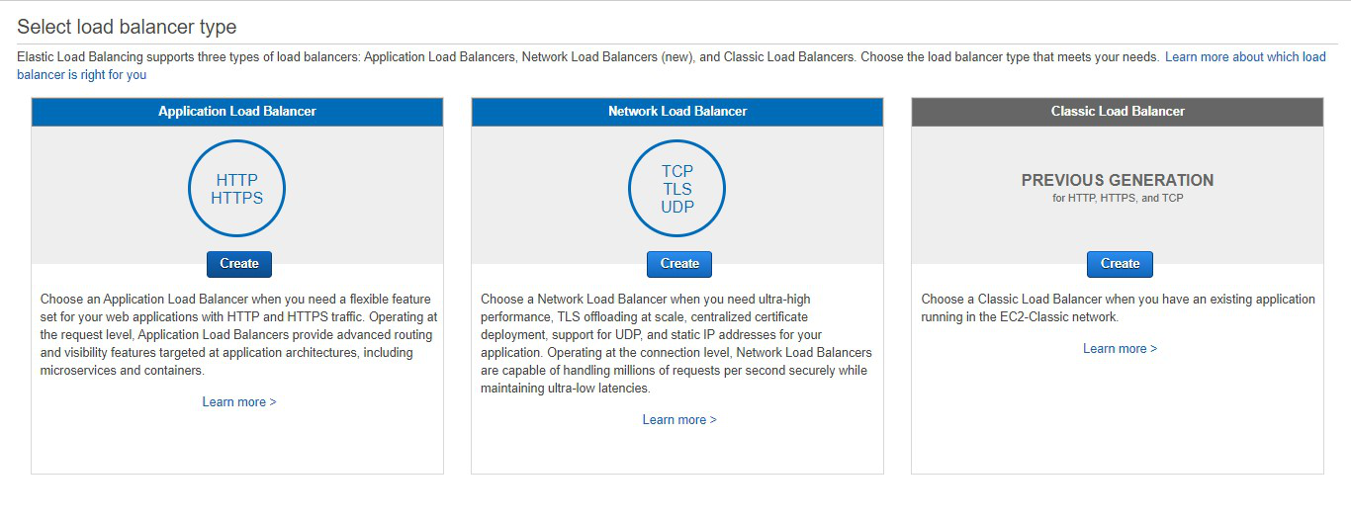

**Step 4: Here you are required to configure the load balancer. Write the name of the load balancer. Choose the scheme as internet facing.**

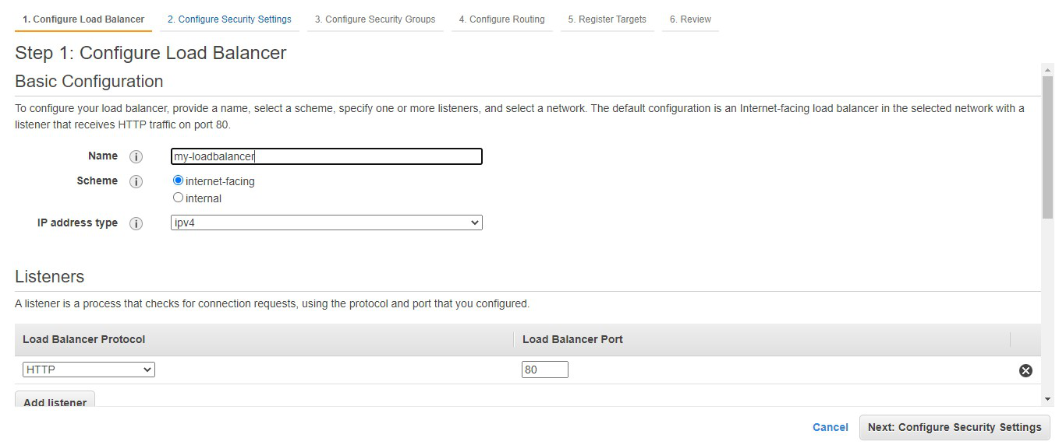

**Step 5: Add at least 2 availability zones. Select us-east-1a and us-east-1b**

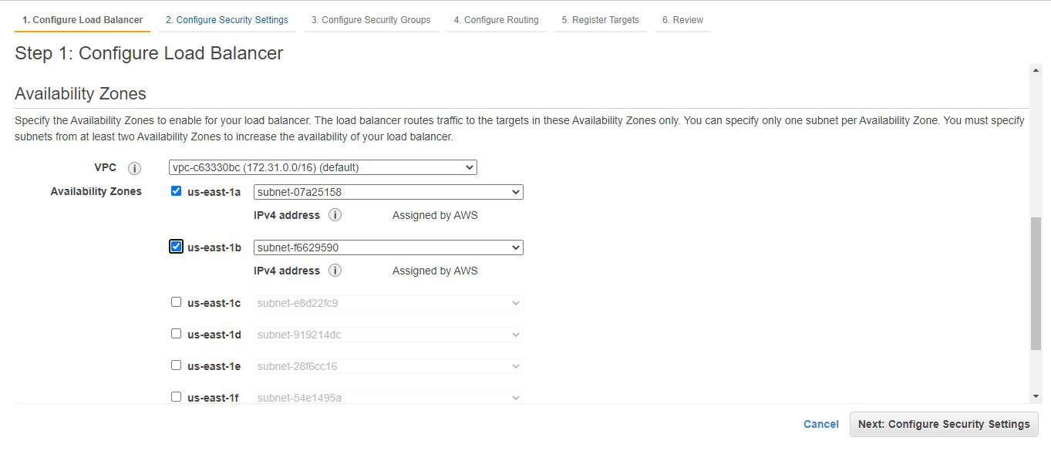

**Step 6: We don’t need to do anything here. Click on Next: Configure Security Groups**

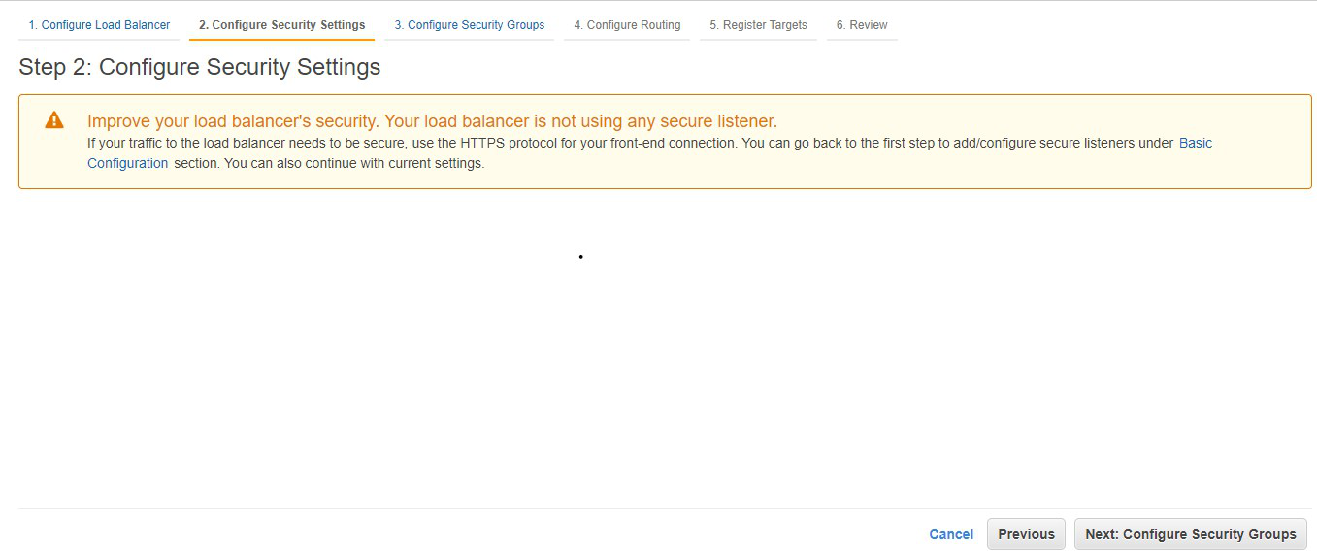

**Step 7: Select the default security group. Click on Next: Configure Routing**

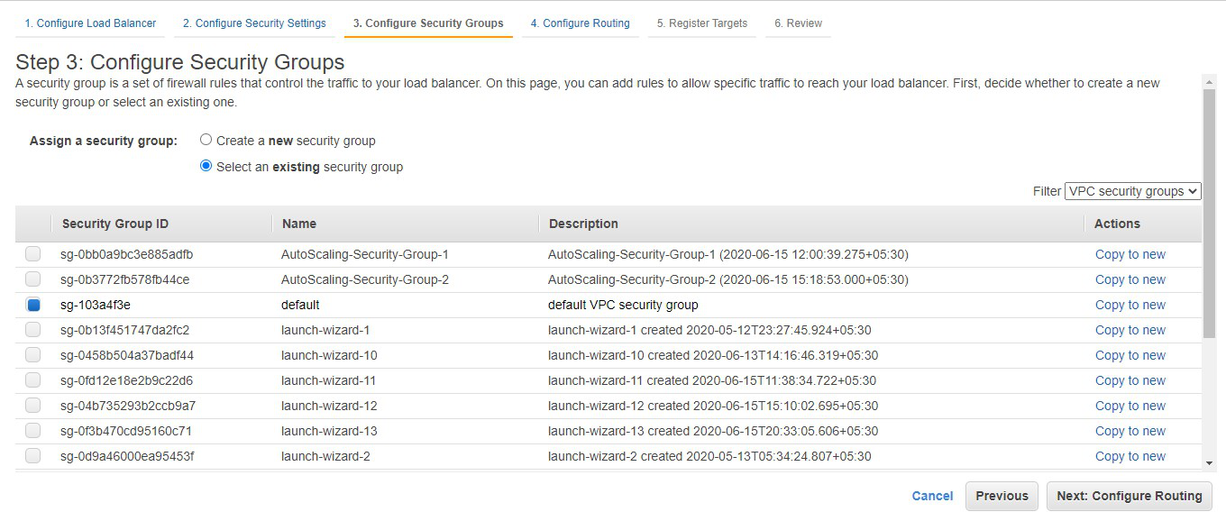

**Step 8: Choose the name of the target group to be my-target-group. Click on Next: Register Targets.**

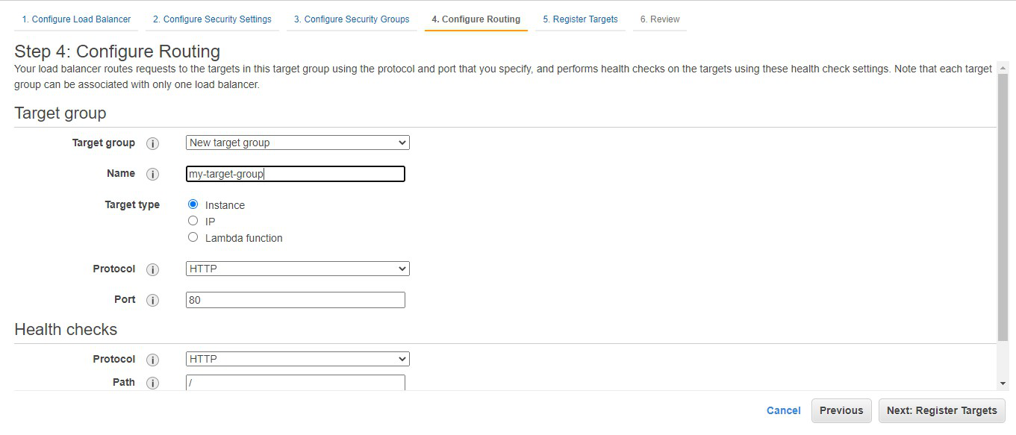

**Step 9: Choose instance A and instance B and click on Add to registered. Click on Next: Review.**

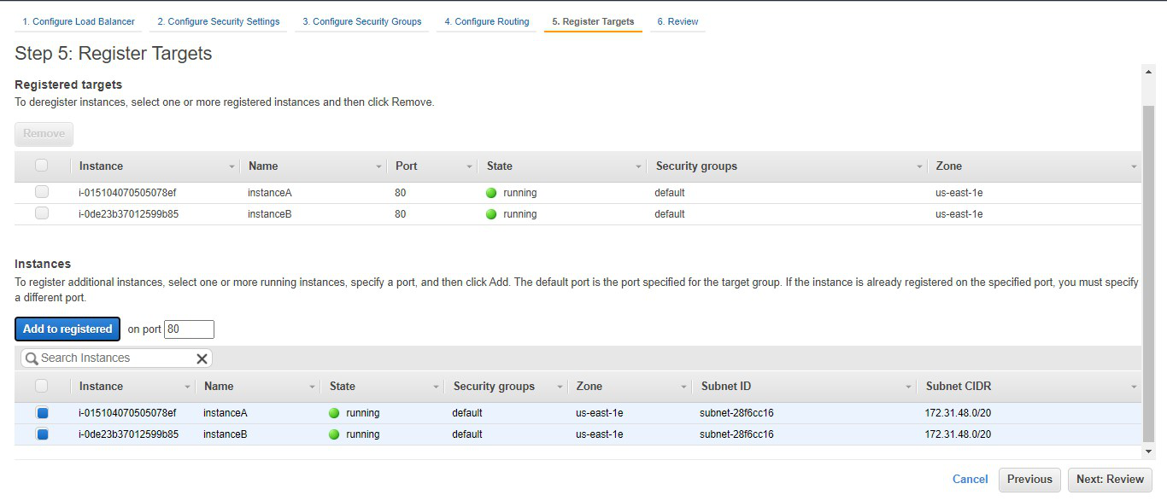

**Step 10: Review all the configurations and click on create**

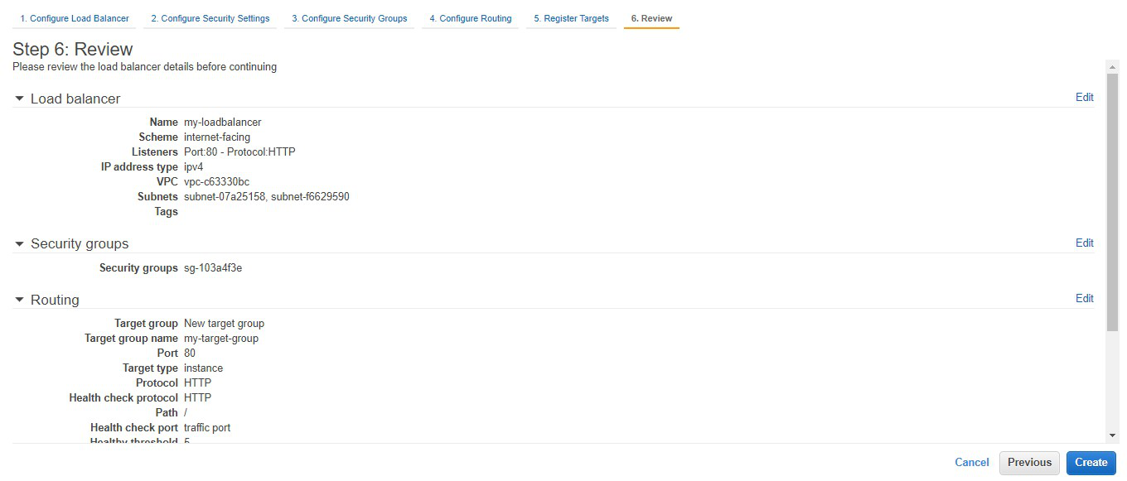

**Step 11: Congratulations!! You have successfully created a load balancer. Click on close.**

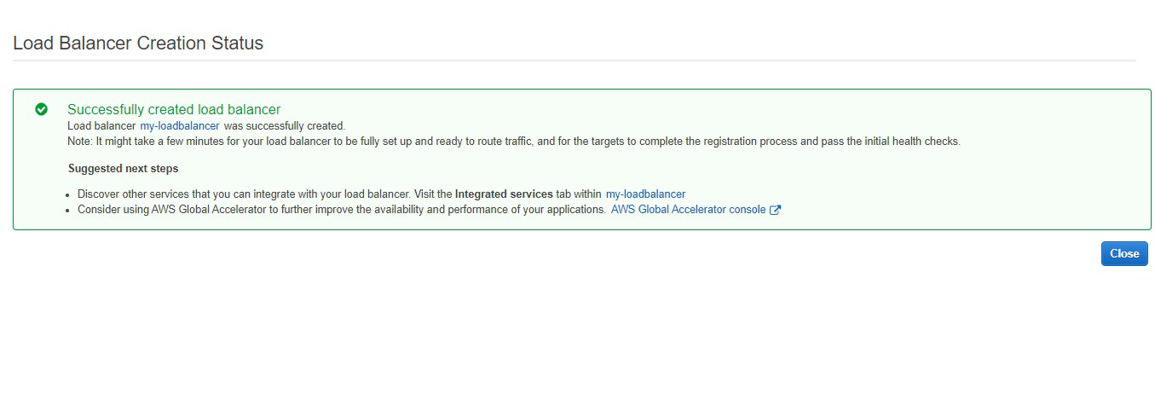

**Step 12: This highlighted part is the DNS name which when copied in the URL will host the application and will distribute the incoming traffic efficiently between the two instances.**

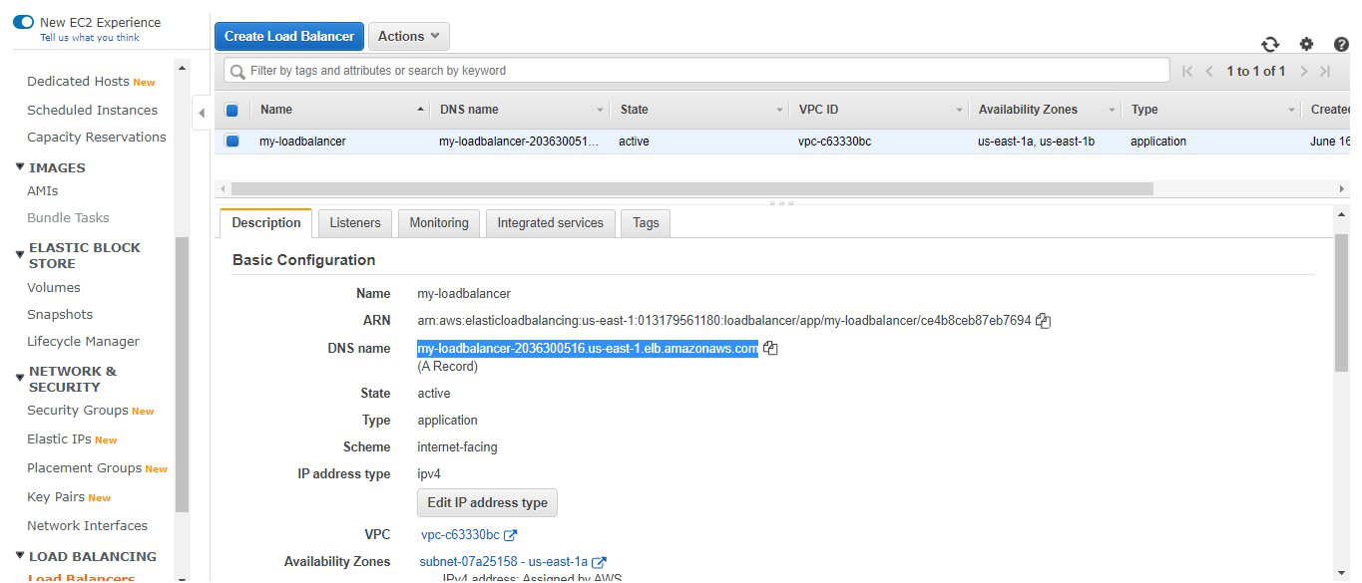

**Step 13: This is the listener port 80 which listens to all the incoming requests**

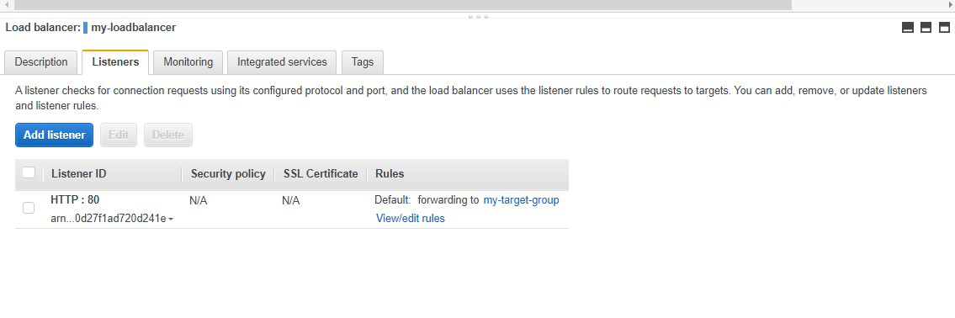

**Step 14: This is the target group that we have created**

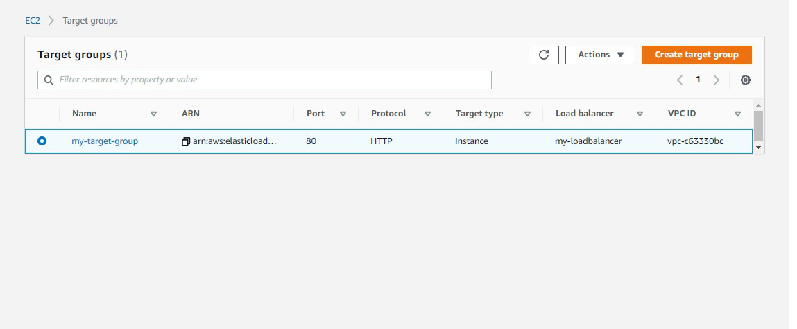

**Step 15: Now we need to delete the instance. Go to Actions -> Click on Delete.**

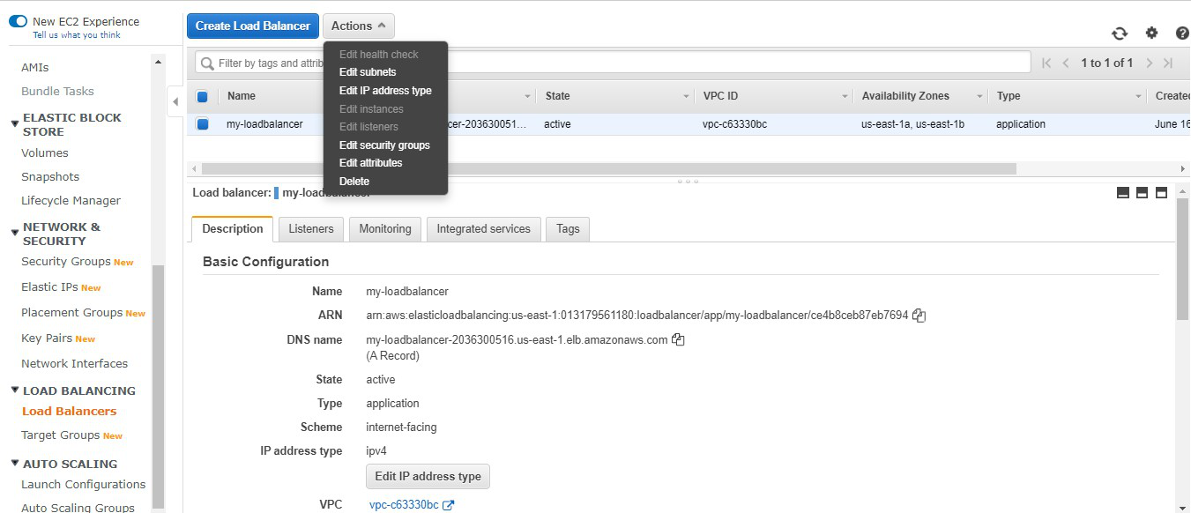

**Step 16: Also don’t forget to terminate the instances.**

